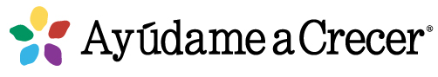
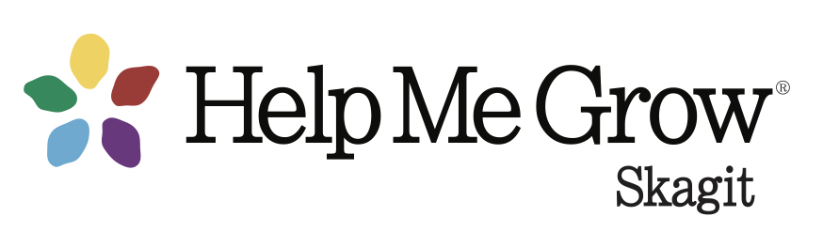
Skagit County Prenatal to Three Network Meeting
Minutes
August 31,2023
8:30 – 9:20 am
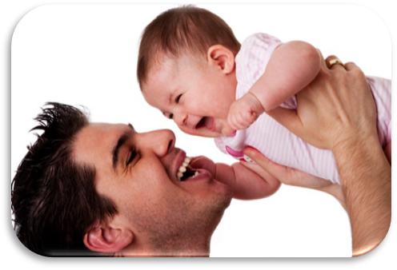
Networking & professional support for providers who serve families during pregnancy through the toddler years

Attendance: Lucinda Ewing, Teri Shilling, Alison Burton, Miranda Hastings, Rachelle Bellefleur, Susan Goss, Addelle Diedesh, Mary Ellen Lykins, Lyndie Simmonds, Keri Nguyen, Jodie Solberg, Janna Uffelman, Jacqueline Rocha, Christi Brua-Weaver, Cecilia Saldana, Wende Dolstad, Rosa Paz, Sydney Costello, Crystal Kombol, Heidi Mitchell-Sanchez, SCPH (Sarah Webb?)
Welcome & Introductions – All

Help Me Grow Skagit
- Family Resource Center updates: new interim manager, working on expanding family education and support programming. Offering “Dad & Me at CMSC” special sessions for fathers and their children and “Sensory Explorations” sessions for families with children with sensory challenges. Family Resource Navigator is on site several days/week, as well as by phone to assist families with applying for state resources and connecting with local resources.
- Family & Community Outreach Reminders
  - Family Palooza November 4, registration link:
  - Bright By Text

    - online message request form!
- Child Development content preview

Perinatal Mental Health – Janna Uffelman
- Perinatal Education & Resilience Collaborative (PERC) Parent Resilience Program (Flyers attached). PERC offers peer support in the perinatal period, meeting people where they are. When a referral is made (online, through the Perinatal Support WA warm line 1-888-404-7763, or contact Addelle at Addelle.diedesch@perinatalsupport.org), a peer will call with more information and give the “pitch”. Families have been helped with obtaining license renewals, rental support, baby clothes, other tangible needs. Or they may be in a space like “I don’t have friends” or “I don’t want to leave the house with my baby” or other isolating circumstances. The peers will meet people where they are and provide the type of support that the individual needs, focused on a wellness plan. Eventually they would also like to offer group supports. A group peer support training is coming up, so there are opportunities for more people to become group facilitators. Recruiting for a Spanish-speaking peer/Parent Resilience Specialist—let Addelle know if you know of any good candidates.
- Resource list updates English | Spanish

Agency Updates – All
- Overdose awareness event tonight at Skagit County Fairgrounds
- Rachelle reported Skagit Valley Hospital Family Birth Center staff toured didgʷálič Wellness Center yesterday. She has been working to help them get birthing parents started on medications for opioid use disorder and referred for ongoing treatment when needed.
- Help Me Grow WA is working with birth centers across the state to connect families to Plan of Safe Care services if they have infants with prenatal substance use exposure, but do not require a referral to CPS.
- Island Hospital offers in-person childbirth classes with varying schedules. Participants do not need to deliver at Island Hospital to participate. Apple Health can cover the cost of the classes.
- September Lactation coalition meeting is featuring an education event about bottle-refusers (see professional development section, below)
- Pregnancy Connections online referral form is now available on the HMG-Skagit website. Plans are in the works for a new parent/baby class/group in Mount Vernon. Contact Janna at Jannau@co.Skagit.wa.us or 360-770-7743 (call or text) for more info.
- The Holding Space Birth & Wellness Cooperative in Anacortes provides health care and hosts a variety of wellness services and supports childbirth ed, doulas, parent support, lactation support, pregnancy/stillbirth/infant loss support and many other offerings for perinatal well-being.
- Susan will soon be working on a landscape assessment of classes and supports prenatal through early childhood, which will provide our Help Me Grow system with information about gaps and opportunities and clearer information for families.

Resources, etc.
- Find breastfeeding classes, Bringing Baby Home and more at https://unitedgeneral.org/classes/
- Classes & Groups at The Holding Space Birth and Wellness Cooperative, including weekly “Lactation Lounge” infant feeding support, “Strong as a Mother” support for pregnancy and infant loss, prenatal and childbirth ed classes and more
- Fathering in 15 Fifteen free 15-minute online modules for fathers/father figures
- Infant Feeding Information & Support Group second monthly Tuesday at 4:30pm; Fourth monthly Thursday at 10:30am. at the Mount Vernon Birth Center.
- Free Parent Leadership Institute with 5 free college credits starts September 16. Info in Spanish is available here

Professional Development/Webinars
- Motivational Interviewing training 9/22, great bargain at $20!
- Development Is a Journey: A Conversation Roadmap for Talking with Families, September 20
- Bottle Skills for the Bottle Refuser, sponsored by the Skagit Lactation Coalition, Sept. 27
- More offerings from the WA Association of Infant Mental Health https://www.wa-aimh.org/training

Next meeting: November 30, 2023

2024 meeting schedule: February 29 (it’s Leap Year!), May 30, August 29, October 31

