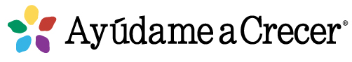
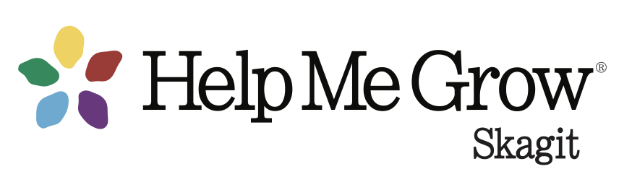
Skagit County Prenatal to Three Network Meeting
Agenda
March 30,2023
8:30 – 9:30 am

Networking & professional support for providers who serve families of pregnant women, infants and toddlers

Welcome & Introductions – All

Help Me Grow Skagit
- Family Resource Center updates
- Family & Community Outreach
  - Family Palooza April 22nd
  - Just Between Friends Consignment Sale 4/19-4/25
  - Bright By Text – new online message request form!
- Child Health Care Provider Outreach
  - Impact of Technology on Child Development, 4/20
  - Pediatric Gait, 5/18

Perinatal Mental Health - T. Addelle Diedesch, MA, LMHC, PMH-C
- Perinatal Education & Resilience Collaborative Parent Resilience Program
- Groups – Little Mountain Counseling, Youthnet
- Perinatal Mental Health training April 14 & 21
- Resource list updates English | Spanish

Agency Updates – All
- Congratulations to Diane Marx on her retirement from Community Action WIC!
- Welcome to Angie Hotz, LM, CPM, new owner of Mount Vernon Birth Center

Resources, etc.
- Classes & Groups at The Holding Space
- Virtual “Baby Lounge” support group
- Lactation website for working moms
- Apple Health Ambassador information

Professional Development/Webinars
- 2023 Maternal Health Tribal Learning Community Series
- 2023 Washington Fatherhood Summit May 16-18
- Dad Allies Provider Learning Series
- Brazelton Touchpoints Learning to Listen series on YouTube

Next meetings: June 29, September 28

