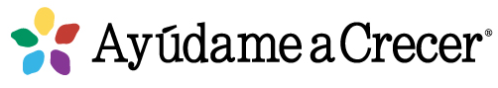
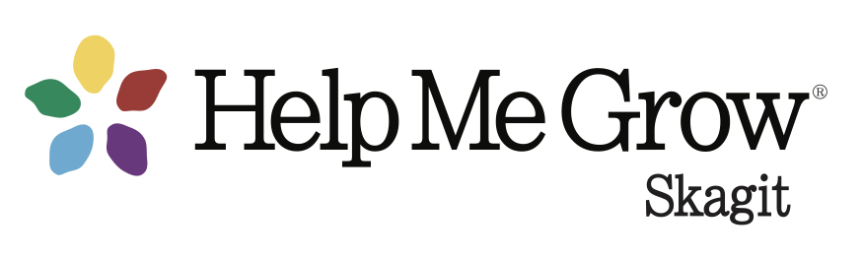
Skagit County Prenatal to Three Network Meeting Minutes
June 30,2022
8:30 – 9:30 am

Networking & professional support for providers who serve families of pregnant women, infants and toddlers

Attendance: Wende Dolstad, Lucia Cantu, Iris Carias, Ana Rivas, Addelle Diedesch, Janna Uffelman, Teri Shilling, Stacey Anderson, Allison Burton, Gaby Camarena, Rosa Paz, Emily Molina, Heidi Mitchell-Sanchez, Rachelle Bellefleur, Lucinda Ewing, Charlene McPherson, Jhaveena Broadnax, Marcelina Mendoza, Delenee Brugman, Jennifer Sass-Walton, Jennifer Duvall, Jennifer McCabe

Nurture Peer Support Program—Jennifer Duvall, Senior Program Manager
(Soon to be named Nurture NW, as they can serve beyond the Seattle area.) Nurture is a 1:1 text-based perinatal peer support program based on a program from Pittsburgh called Nurture PA. Committee for Children is well known for social-emotional curriculum like Second Step® which is implemented in school districts across the country and internationally. They adopted the Nurture program after seeking a way to support social-emotional well-being prior to school entry, during the transition to parenthood, with a program that can be scaled. Nurture PA meets with parents at the hospital 24 hours post birth. Parents sign up with iPad and are matched with a volunteer parent mentor at no cost to the parent. All support is offered via text, with no sharing of last names, photos, etc. Parents and mentors communicate regularly. The mentor communicates via a computer program, parent gets text. They have had incredible success with engagement and retention. Parents report feeling more confident and connected with their children.

The Nurture Seattle pilot launched April 2020, and they couldn’t go into the hospital to recruit due to the pandemic, so they recruited via social media and other means. The founding mentors shaped the program from beginning. Parents wanted to talk about emotional well-being (Nurture PA was focused more on child development, interactions). Parents can sign up at any time during pregnancy through 6 months post-birth, and they are matched in their 3rd trimester with support through their child’s 1st birthday. Eventually support may extend beyond the first birthday. No income requirements. Currently only available in English, as they are looking for a community manager to support Spanish. Parents can describe identity, concerns, preferences for their match.
Parents are encouraged to become mentors when they graduate, and about ¼ opt to do this.

Each mentor can support up to 10 parents, takes 1-2 hours per week. Nurture provides training, materials, support and supervision. Mentors reply to texts within 24 hours, send check-in at least once/week. Conversation starters are already plugged in. Mentors have resources they can attach in text.

The results have been encouraging, and Nurture is involved in a research project with the University of WA.

Parents can sign up for Nurture at https://www.nurtureseattle.org/join

EMBERcenter Peer Support—Jennifer McCabe, Ph.D., Director
The EMBERcenter at Western WA University is offering a text-based perinatal/parent peer support program at no cost to families. Although they are based in Bellingham, they can serve parents more broadly, as they are funded by the WA State Department of Health. Support is available to parents who are expecting a baby or have a child up to age 3. This peer support model is based on a program in the UK for home visitors utilizing supportive listening and has been adapted to be delivered by peers rather than home visitors. This has been offered in the UK for decades and has been shown to be very helpful in preventing/treating depression, anxiety. Individuals who identify with perinatal population can volunteer to receive training as mentors. Peer bios are available online. Parents can connect with someone they identify with. Support is offered via text, phone or video chat. The parent and peer negotiate a schedule that works for them, usually weekly for four weeks. At the end, parents are invited into other supports or given options for mental health services. Support can be provided in any language that the support people speak—currently English and Spanish. They currently have 20 support people, three Spanish-speakers, one a Lummi member and someone who has experienced teen pregnancy and being homeless

They are trying to overcome as many barriers as possible. The current referral pathway is through Whatcom County’s Single Entry Access to Services (SEAS) line, but that may change. A SEAS navigator completes a broader SEAS intake and a brief depression screening (Edinburgh). The only things that disqualify someone for peer support are if they score in severe range of symptoms or express suicidal ideation.

Locally, we can connect families directly to the EMBERcenter for more info: 360-650-7535 or embercenter@gmail.com

Agency Updates – All
- Sea Mar MSS: We continue to accept referrals for Medicaid eligible pregnant and parenting families until baby's 1st year. (They do not have to be Sea Mar patients to qualify for our support program). Jaqueline Rocha - one of our Infant Case Managers (who usually attends these meetings) is leaving us and today 6/30 is her last day. We still have a full team at Sea Mar MSS (two nurses, a social worker, a community health worker and your new contact for the Infant case manager: Daisy Camarena. I have a position open for Social Worker - split Whatcom and Skagit county. I also have an opening for On Call Community Health worker. (both are bilingual Spanish preferred) Please reach out to me with any questions. LuciaCantu@seamarchc.org 360-398-5458
- Agriculture season is in full swing. Iris is available to help support migrant/agricultural worker families.
- The Diaper Bank of Skagit County is hosting a “Stuff the Bus” event at Skagit County Fair on August 10. The first 200 people who bring an unopened pack of diapers to the Fair on that day get a free ticket to the Fair.
- A County Commissioners proclamation for National Breastfeeding Month/World Breastfeeding Week on Tuesday, July 26 at 3 pm.
- Dr. Jody Cousins will be providing a medical education event Supporting Breastfeeding Families: Implementing a Primary Care Office Strategy on August 2 at 7 a.m.
- Gaby Camarena, our Help Me Grow Skagit Family Resource Navigator is now on site at the Children’s Museum/Family Resource Center on Tuesdays and Thursdays.
- Pregnancy Connections Nurse: Any family in Skagit County can call or text 360-770-7743 and be connected with a nurse who will provide local pregnancy-specific information and referral.
- New Maternal Mental Health Hotline available: The federal Health Resources and Services Administration (HRSA) has launched a national Maternal Health Hotline, a 24/7 free resource for pregnant, new mothers, and birthing people facing mental health challenges. Learn more about this confidential hotline for pregnant and new moms on HRSA’s webpage.
- In addition, Washington State has two existing lines dedicated to supporting pregnant and parenting individuals as well as providers working with these populations.
  - Perinatal Support Washington (PS-WA) Parent Warm Line: The Perinatal Support Washington (PS-WA) Parent Support Warm Line (call or text) remains an excellent resource with local knowledge of referrals for community members who are seeking non-urgent support in Washington state in English and Spanish. The Warm Line is answered by trained parents who have experienced and recovered from a perinatal mental health issue. Those reaching out to the Warm Line receive ongoing emotional support beyond the initial conversation, wellness planning, and targeted referrals to available providers and community services.
    - Number: 1-888-404-7763
    - Hours: 9 A.M. - 4:30 P.M., Monday- Friday. On evenings and weekends, calls will be returned within 1-14 hours.
  - University of Washington Perinatal Psychiatry Consultation Line (Perinatal PCL): The HCA-funded University of Washington Perinatal Psychiatry Consultation Line offers free, timely telephone consultation to health care providers in Washington State about their patients/clients with mental health and/or co-occurring substance use concerns who are pregnant, postpartum, planning pregnancy, or experiencing pregnancy complications (e.g., infertility, pregnancy loss). Perinatal PCL offers telephone consultation with a perinatal psychiatrist within 24 hours (85% of calls directly connected), written recommendations, referral assistance, and an online perinatal mental health care guide.
    - Providers can call Perinatal PCL at 877-725-4666 weekdays 9 A.M. - 5 P.M., or by email.
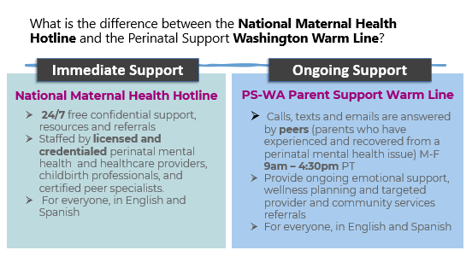
Resources
- www.helpmegrowskagit.com
- Resources for Practice Caregiver Handouts: Games and Activities
- expansion of Medicaid coverage for the year after pregnancy.
  - Link: Apple Health After-Pregnancy Coverage (English)
  - Translations: Top 15 translations

Professional Development/Webinars
- UW Moms’ Access Project: Perinatal Substance Use, Mental Health and Infant Mental Health Case Conference Series
- THE BORDER IS HERE: Immigration Trauma and Loss, July 26 9-11 a.m. via Zoom
- Most Dads Are Not Violent. What If They Are? September 22, 11:30 am to 1:00 pm
- WA-AIMH has launched new webpages where all information regarding DC:0-5™ training for Apple Health professionals can be found. Please visit these webpages to learn about the benefits of DC:0-5™ training for you or your organization, find resources about the DC:0-5™, or even apply to become a certified DC:0-5™ trainer.

Next meeting: September 29


