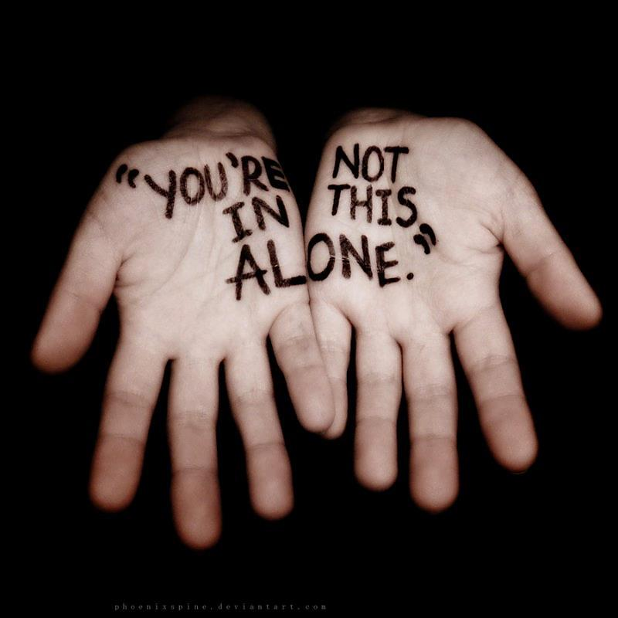

**Parents of Sexual Abuse Survivors**

**Support Group**

C:\STOCKLAYOUTS\CURRENT PROJECTS\FN99807-PL\FN99807-IMG05.emf



**T. Addelle Diedesch MA, LMHCA, MHP**

**Phone: 360-419-3622**

**For information please contact**

1005 South 3rd Street

Mount Vernon, WA 98273

**Sexual abuse and assault impacts both children *and* their caregivers.**

If you are a parent of a child who has been sexually assaulted, you are not alone. There is *help*…and there is *hope*.

Research shows that *1 out of 4 girls* and *1 out of 6 boys* will experience some form of sexual abuse before they are 18 years old.

Compass Health is offering an

8-week support group for *non-offending* parents or caregivers of sexually abused children.

This group is at no cost to participants.

**WHEN**:

Mondays for 8 weeks

April 16th – June 4th

**TIME**:

4:30-6:00PM

**WHERE**:

Compass Health Child and Family Services